Update for key stakeholders
9 December 2022

Vaccination
NHS Highland has 146 active clinic locations (on average, other Boards have 26).
As at 27 November, we had carried out a total of 112,710 COVID vaccinations and 131,659 flu vaccinations as part of the winter 22-23 vaccination programme. Vaccination figures across the whole of the NHS Highland area are:
 | Over 65s % complete | Health & social care staff % complete | 5-65s at risk % complete
COVID | 84.4 | 45.9 | 47.7
Flu | 78.3 | 44.1 | 43.0

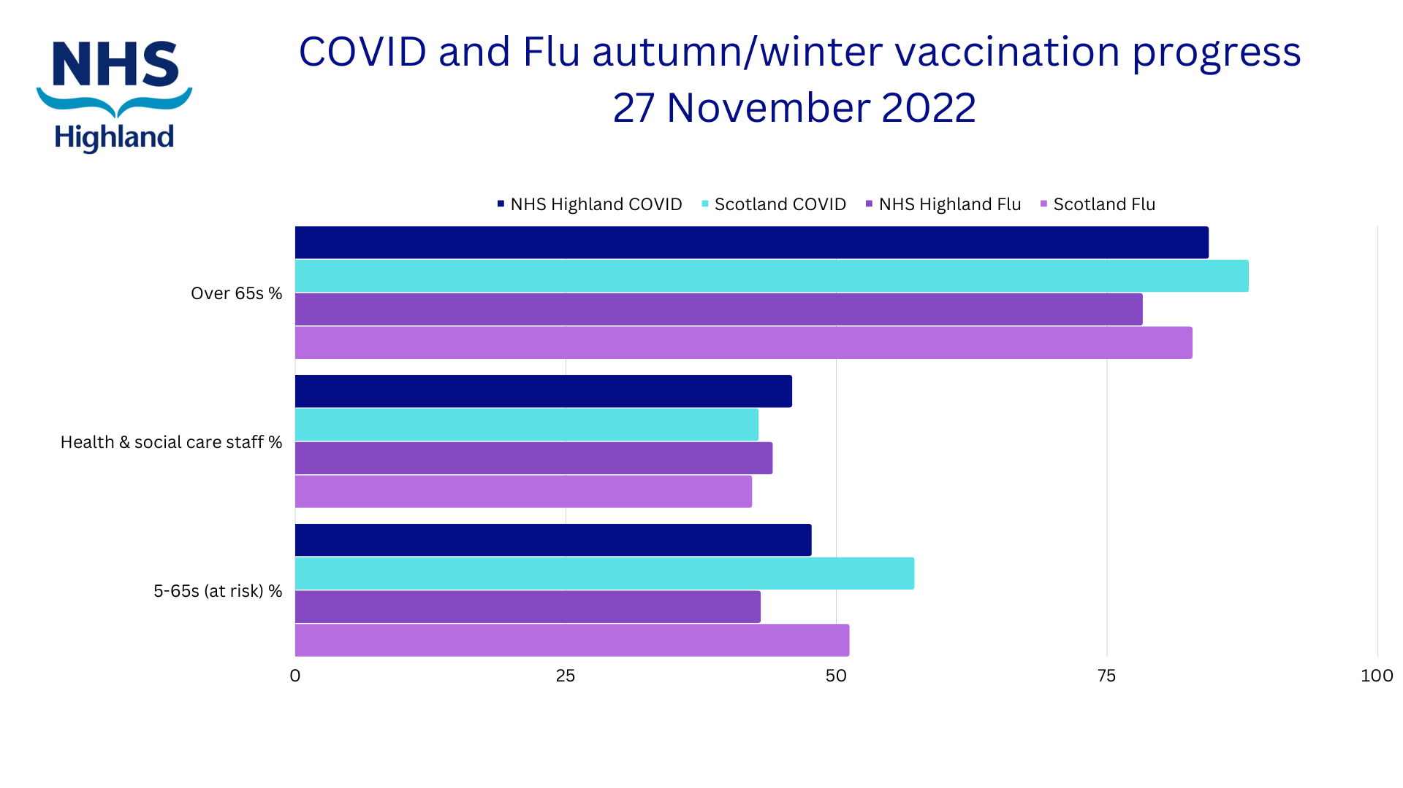
Social Care Reserves
NHS Highland’s Care Reserves is a new initiative created to enhance support to the care sector during a time of fragility following the pandemic and in preparation for winter pressures. The aim is for services in need of support will be able to call upon Reserves for extra resources. Reserves will be made up of people working flexible, who may or may not already have care experience. We are looking for people who are retired, looking to return to work or are already employed but have extra hours available.

This is a Highland-wide advert and we would welcome people in rural communities as well as the city to apply. (Social care in Argyll and Bute is managed by Argyll and Bute Council.) Any offer of support will be gratefully considered and we will look to match Reserves to their local communities. The commitment and roles are varied and negotiable. Duties may include personal care assistance, driving, food preparation, laundry, house-keeping, companionship, responder or care duties. NO previous care experience is required and training and mentoring will be provided before work begins. Fair pay will be provided in line with NHS Scotland agenda for change. This post is for a Band 3 health and social care support worker.

Please share this opportunity. Anyone who may be interested can contact Laura (0797 7140749) or Ariane (0797 7048903) for an informal chat or email nhsh.carereserves@nhs.scot

Preparing for winter
We are preparing for a challenging winter, given the existing pressures on the whole of the NHS and care system, and elements such as the cost of living. You can help by directing constituents to the most appropriate place for their care.
Local A&E departments across Highland and Argyll and Bute remain open for those who have a life-threatening emergency. Anyone with a non-life threatening condition who cannot wait to see their GP should call NHS 24 on 111 first to be directed to the right NHS service. This may be A&E, a minor injuries clinic, a phone or virtual appointment, or a pharmacy, GP or dentist. 111 is available 24 hours a day, 7 days a week and is suitable for a range of concerns including cuts, burns, suspected broken bones, sprains and other injuries or illnesses.

There is also an NHS 111 online service where people can get help for your symptoms.

People can also help to keep themselves safe and well by keeping warm, making sure vaccinations are up to date, having enough medication in stock, and staying active. NHS Inform has specific advice on staying well this winter.

Feedback
If you have comments or queries please contact nhshighland.feedback@nhs.scot

